clustering dest_wallet_id

آزمایشی

Exported on 2023-08-01 19:02:59

Table of Contents

1 براساس wallet_nickname 4

2 براساس count, transaction_cost, transaction_value 6

* clustering dest_wallet_id
  + براساس wallet_nickname
    - میانگین transaction_value ها
      * براساس مقیاس معمولی
      * نحوه‌ی توزیع wallet_nickname های غیر null
  + براساس count, transaction_cost, transaction_value
    - نسبت مجموع transaction_value ها به مجموع transaction_cost ها:
      * براساس مقیاس معمولی
      * براساس مقیاس کوچک شده‌ی 100000 برابری
      * بر اساس توزیع نسبت
    - نسبت مجموع transaction_cost ها به مجموع transaction_value ها:
      * براساس مقیاس معمولی
      * براساس مقیاس کوچک شده‌ی 100000 برابری
      * براساس توزیع نسبت
    - مجموع transaction_value ها با transaction_cost ها
      * براساس مقیاس معمولی
      * براساس مقیاس کوچک شده‌ی 100000000 برابری
    - مجموع transaction_value ها
      * براساس مقیاس معمولی
      * براساس مقیاس کوچک شده‌ی 100000000 برابری
    - مجموع transaction_cost ها
      * براساس مقیاس معمولی
      * براساس مقیاس کوچک شده‌ی 100000000 برابری
    - میانگین transaction_cost ها
      * براساس مقیاس معمولی
      * براساس مقیاس کوچک شده‌ی 100000000 برابری
    - میانگین transaction_value ها
      * براساس مقیاس معمولی
      * براساس مقیاس کوچک شده‌ی 100000000 برابری

# براساس wallet_nickname

* **میانگین transaction_value ها**
  + **براساس مقیاس معمولی**

|  |
| --- |
| **select** count(*), 'wallet_nickname is null and not null' **from**(  **select** **distinct** dest_wallet_id **from** data_dataset **where** wallet_nickname **is** null  **intersect** all  **select** **distinct** dest_wallet_id **from** data_dataset **where** wallet_nickname **is** not null) **as** t  **union**  **select** count(*), 'wallet_nickname is null ' **from**(  **select** **distinct** dest_wallet_id **from** data_dataset **where** wallet_nickname **is** null  **except** all  **select** **distinct** dest_wallet_id **from** data_dataset **where** wallet_nickname **is** not null) **as** t  **union**  **select** count(*), 'wallet_nickname is not null ' **from**(  **select** **distinct** dest_wallet_id **from** data_dataset **where** wallet_nickname **is** not null  **except** all  **select** **distinct** dest_wallet_id **from** data_dataset **where** wallet_nickname **is** null) **as** t  **order** **by** count **desc** |

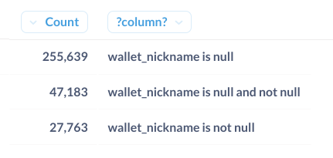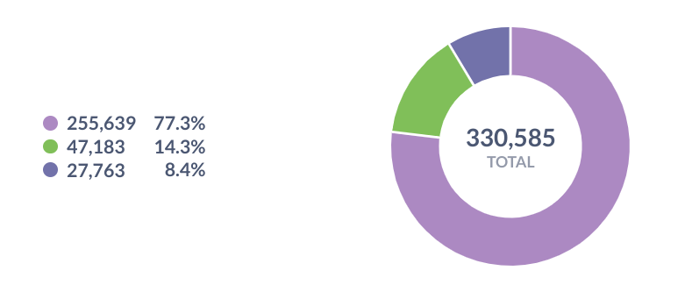

* + **نحوه‌ی توزیع wallet_nickname های غیر null**

|  |
| --- |
| **select** dest_wallet_id, count(*) ta_wallet_nickname, sum(tedad) bar_tekrar_shodan  **from**(  **select** dest_wallet_id, wallet_nickname, count(*) tedad  **from** data_dataset  **where** wallet_nickname **is** not null  **group** **by** dest_wallet_id, wallet_nickname ) **as** t  **group** **by** dest_wallet_id  **order** **by** ta_wallet_nickname **desc**, bar_tekrar_shodan **desc** |

* + - توزیع wallet_nickname های متمایز

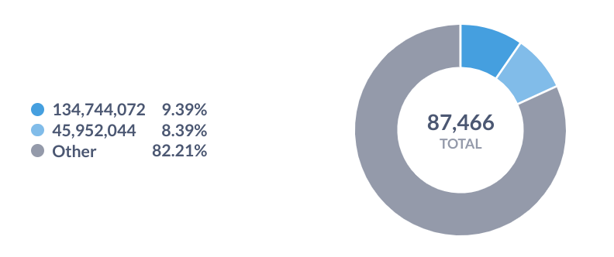

* + - تعداد تکرار walletـnickname خاص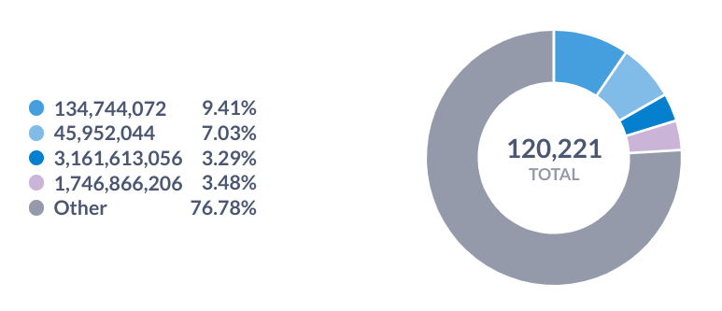

# براساس count, transaction_cost, transaction_value

* **نسبت مجموع transaction_value ها به مجموع transaction_cost ها:**
  + **براساس مقیاس معمولی**

|  |
| --- |
| **select** dest_wallet_id, swtv/greatest(swtc,1) result  **from**(  **select** dest_wallet_id, sum(transaction_value) swtv, sum(transaction_cost) swtc  **from**(  **select** dest_wallet_id, sum(new_count) wight, transaction_cost, transaction_value  **from**(  **select** *  **from**(  **select** dest_wallet_id, count(count) new_count, transaction_cost, transaction_value  **from** data_dataset  **where** count = 0  **group** **by** dest_wallet_id, transaction_cost, transaction_value) **as** b0    **union** all  **select** *  **from**(  **select** dest_wallet_id, count new_count, transaction_cost, transaction_value  **from** data_dataset  **where** count != 0) **as** b1) **as** b2  **group** **by** dest_wallet_id, transaction_cost, transaction_value) **as** b3  **group** **by** dest_wallet_id) **as** b4  **order** **by** result **desc** |

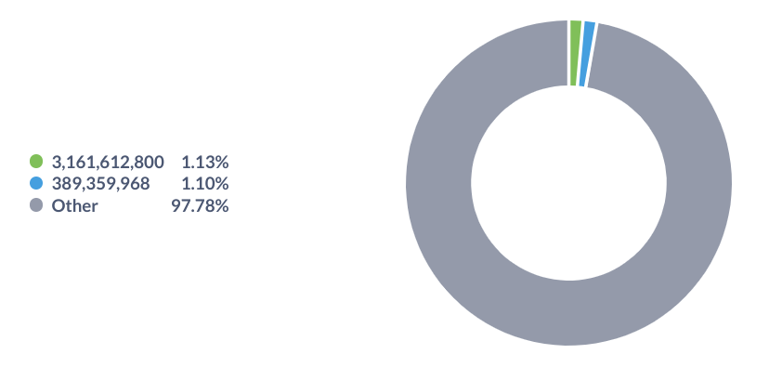

* + **براساس مقیاس کوچک شده‌ی 100000 برابری**

|  |
| --- |
| **select** dest_wallet_id/100000 dest_wallet_id, sum(swtv)/greatest(sum(swtc),1) result  **from**(  **select** dest_wallet_id, sum(transaction_value) swtv, sum(transaction_cost) swtc  **from**(  **select** dest_wallet_id, sum(new_count) wight, transaction_cost, transaction_value  **from**(  **select** *  **from**(  **select** dest_wallet_id, count(count) new_count, transaction_cost, transaction_value  **from** data_dataset  **where** count = 0  **group** **by** dest_wallet_id, transaction_cost, transaction_value) **as** b0    **union** all  **select** *  **from**(  **select** dest_wallet_id, count new_count, transaction_cost, transaction_value  **from** data_dataset  **where** count != 0) **as** b1) **as** b2  **group** **by** dest_wallet_id, transaction_cost, transaction_value) **as** b3  **group** **by** dest_wallet_id) **as** b4  **group** **by** dest_wallet_id/100000  **order** **by** result **desc** |

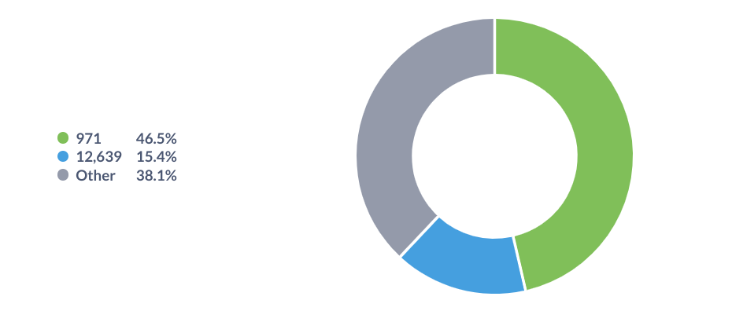

* + **بر اساس توزیع نسبت**

|  |
| --- |
| **select** count(*), (**select** count(*) **from**(**select** **distinct** dest_wallet_id **from** data_dataset) **as** b8) total  **from**(  **select** dest_wallet_id, swtv/greatest(swtc,1) result  **from**(  **select** dest_wallet_id, sum(transaction_value) swtv, sum(transaction_cost) swtc  **from**(  **select** dest_wallet_id, sum(new_count) wight, transaction_cost, transaction_value  **from**(  **select** *  **from**(  **select** dest_wallet_id, count(count) new_count, transaction_cost, transaction_value  **from** data_dataset  **where** count = 0  **group** **by** dest_wallet_id, transaction_cost, transaction_value) **as** b0    **union** all  **select** *  **from**(  **select** dest_wallet_id, count new_count, transaction_cost, transaction_value  **from** data_dataset  **where** count != 0) **as** b1) **as** b2  **group** **by** dest_wallet_id, transaction_cost, transaction_value) **as** b3  **group** **by** dest_wallet_id) **as** b4) **as** b5  **where** result > 1  --where result = 1  --where result < 1 |

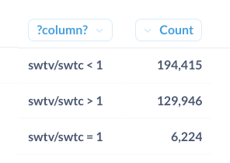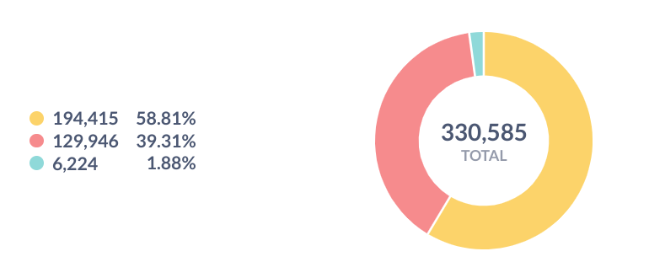

* **نسبت مجموع transaction_cost ها به مجموع transaction_value ها:**
  + **براساس مقیاس معمولی**

|  |
| --- |
| **select** dest_wallet_id, swtc/greatest(swtv,1) result  **from**(  **select** dest_wallet_id, sum(transaction_value) swtv, sum(transaction_cost) swtc  **from**(  **select** dest_wallet_id, sum(new_count) wight, transaction_cost, transaction_value  **from**(  **select** *  **from**(  **select** dest_wallet_id, count(count) new_count, transaction_cost, transaction_value  **from** data_dataset  **where** count = 0  **group** **by** dest_wallet_id, transaction_cost, transaction_value) **as** b0    **union** all  **select** *  **from**(  **select** dest_wallet_id, count new_count, transaction_cost, transaction_value  **from** data_dataset  **where** count != 0) **as** b1) **as** b2  **group** **by** dest_wallet_id, transaction_cost, transaction_value) **as** b3  **group** **by** dest_wallet_id) **as** b4  **order** **by** result **desc** |

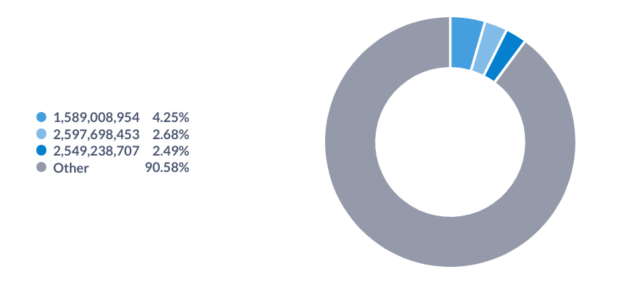

* + **براساس مقیاس کوچک شده‌ی 100000 برابری**

|  |
| --- |
| **select** dest_wallet_id/100000 dest_wallet_id, sum(swtc)/greatest(sum(swtv),1) result  **from**(  **select** dest_wallet_id, sum(transaction_value) swtv, sum(transaction_cost) swtc  **from**(  **select** dest_wallet_id, sum(new_count) wight, transaction_cost, transaction_value  **from**(  **select** *  **from**(  **select** dest_wallet_id, count(count) new_count, transaction_cost, transaction_value  **from** data_dataset  **where** count = 0  **group** **by** dest_wallet_id, transaction_cost, transaction_value) **as** b0    **union** all  **select** *  **from**(  **select** dest_wallet_id, count new_count, transaction_cost, transaction_value  **from** data_dataset  **where** count != 0) **as** b1) **as** b2  **group** **by** dest_wallet_id, transaction_cost, transaction_value) **as** b3  **group** **by** dest_wallet_id) **as** b4  **group** **by** dest_wallet_id/100000  **order** **by** result **desc** |

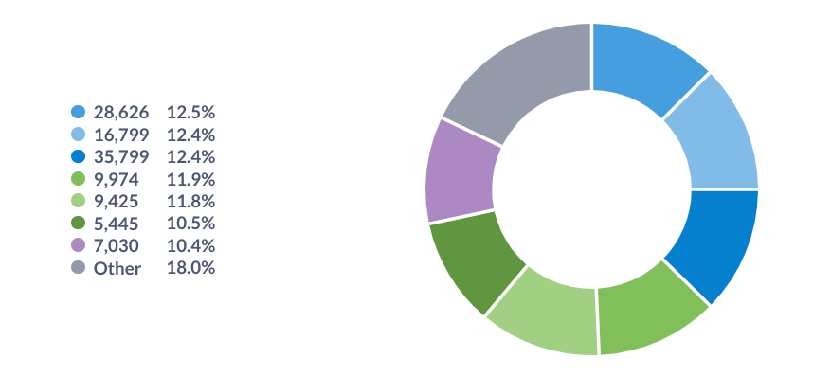

* + **براساس توزیع نسبت**

|  |
| --- |
| **select** count(*), (**select** count(*) **from**(**select** **distinct** dest_wallet_id **from** data_dataset) **as** b8) total  **from**(  **select** dest_wallet_id, swtc/greatest(swtv,1) result  **from**(  **select** dest_wallet_id, sum(transaction_value) swtv, sum(transaction_cost) swtc  **from**(  **select** dest_wallet_id, sum(new_count) wight, transaction_cost, transaction_value  **from**(  **select** *  **from**(  **select** dest_wallet_id, count(count) new_count, transaction_cost, transaction_value  **from** data_dataset  **where** count = 0  **group** **by** dest_wallet_id, transaction_cost, transaction_value) **as** b0    **union** all  **select** *  **from**(  **select** dest_wallet_id, count new_count, transaction_cost, transaction_value  **from** data_dataset  **where** count != 0) **as** b1) **as** b2  **group** **by** dest_wallet_id, transaction_cost, transaction_value) **as** b3  **group** **by** dest_wallet_id) **as** b4) **as** b5  **where** result > 1  --where result = 1  --where result < 1 |

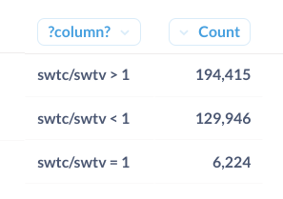

* **مجموع transaction_value ها با transaction_cost ها**
  + **براساس مقیاس معمولی**

|  |
| --- |
| **select** dest_wallet_id, swtc+swtv total  **from**(  **select** dest_wallet_id, sum(transaction_value) swtv, sum(transaction_cost) swtc  **from**(  **select** dest_wallet_id, sum(new_count) wight, transaction_cost, transaction_value  **from**(  **select** *  **from**(  **select** dest_wallet_id, count(count) new_count, transaction_cost, transaction_value  **from** data_dataset  **where** count = 0  **group** **by** dest_wallet_id, transaction_cost, transaction_value) **as** b0    **union** all  **select** *  **from**(  **select** dest_wallet_id, count new_count, transaction_cost, transaction_value  **from** data_dataset  **where** count != 0) **as** b1) **as** b2  **group** **by** dest_wallet_id, transaction_cost, transaction_value) **as** b3  **group** **by** dest_wallet_id) **as** b4--) as b5  **order** **by** total **desc** |

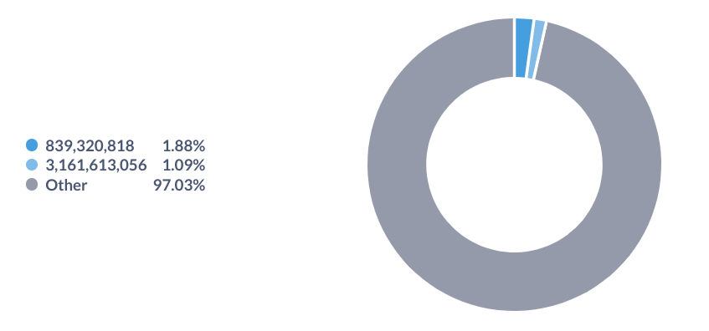

* + **براساس مقیاس کوچک شده‌ی 100000000 برابری**

|  |
| --- |
| **select** dest_wallet_id/100000000 dest_wallet_id, sum(swtc)+sum(swtv) result  **from**(  **select** dest_wallet_id, sum(transaction_value) swtv, sum(transaction_cost) swtc  **from**(  **select** dest_wallet_id, sum(new_count) wight, transaction_cost, transaction_value  **from**(  **select** *  **from**(  **select** dest_wallet_id, count(count) new_count, transaction_cost, transaction_value  **from** data_dataset  **where** count = 0  **group** **by** dest_wallet_id, transaction_cost, transaction_value) **as** b0    **union** all  **select** *  **from**(  **select** dest_wallet_id, count new_count, transaction_cost, transaction_value  **from** data_dataset  **where** count != 0) **as** b1) **as** b2  **group** **by** dest_wallet_id, transaction_cost, transaction_value) **as** b3  **group** **by** dest_wallet_id) **as** b4  **group** **by** dest_wallet_id/100000000  **order** **by** result **desc** |

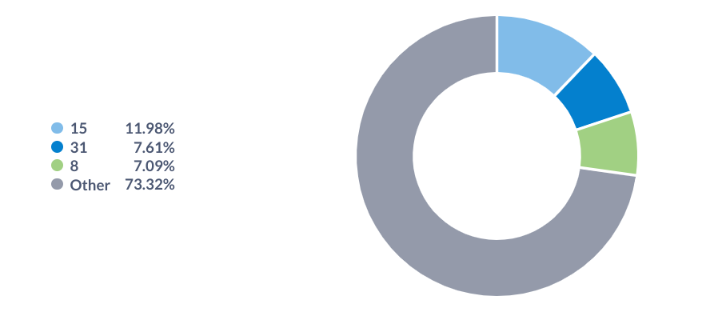

* **مجموع transaction_value ها**
  + **براساس مقیاس معمولی**

|  |
| --- |
| **select** dest_wallet_id, swtv  **from**(  **select** dest_wallet_id, sum(transaction_value) swtv, sum(transaction_cost) swtc  **from**(  **select** dest_wallet_id, sum(new_count) wight, transaction_cost, transaction_value  **from**(  **select** *  **from**(  **select** dest_wallet_id, count(count) new_count, transaction_cost, transaction_value  **from** data_dataset  **where** count = 0  **group** **by** dest_wallet_id, transaction_cost, transaction_value) **as** b0    **union** all  **select** *  **from**(  **select** dest_wallet_id, count new_count, transaction_cost, transaction_value  **from** data_dataset  **where** count != 0) **as** b1) **as** b2  **group** **by** dest_wallet_id, transaction_cost, transaction_value) **as** b3  **group** **by** dest_wallet_id) **as** b4  **order** **by** swtv **desc** |

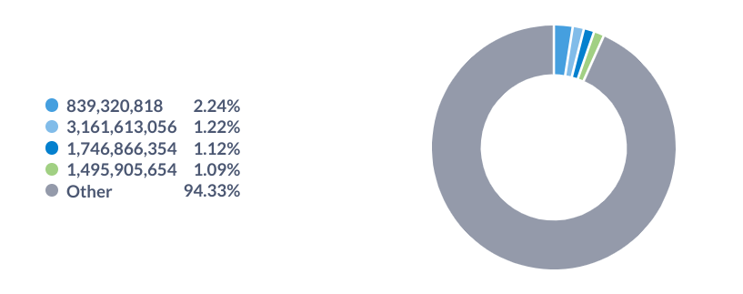

* + **براساس مقیاس کوچک شده‌ی 100000000 برابری**

|  |
| --- |
| **select** dest_wallet_id/100000000 dest_wallet_id, sum(swtv) result  **from**(  **select** dest_wallet_id, sum(transaction_value) swtv, sum(transaction_cost) swtc  **from**(  **select** dest_wallet_id, sum(new_count) wight, transaction_cost, transaction_value  **from**(  **select** *  **from**(  **select** dest_wallet_id, count(count) new_count, transaction_cost, transaction_value  **from** data_dataset  **where** count = 0  **group** **by** dest_wallet_id, transaction_cost, transaction_value) **as** b0    **union** all  **select** *  **from**(  **select** dest_wallet_id, count new_count, transaction_cost, transaction_value  **from** data_dataset  **where** count != 0) **as** b1) **as** b2  **group** **by** dest_wallet_id, transaction_cost, transaction_value) **as** b3  **group** **by** dest_wallet_id) **as** b4  **group** **by** dest_wallet_id/100000000  **order** **by** result **desc** |

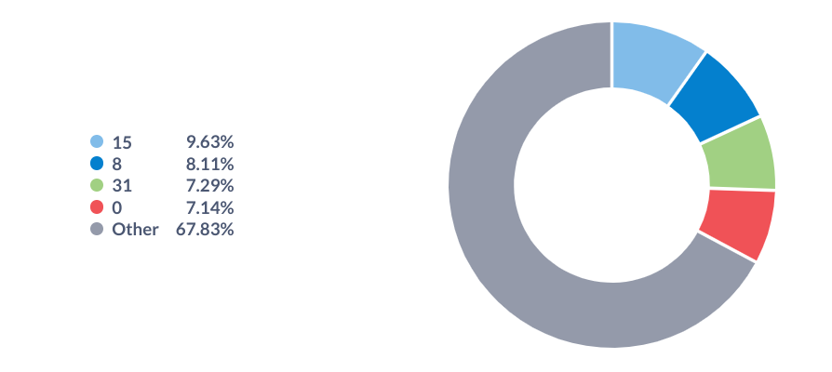

* **مجموع transaction_cost ها**
  + **براساس مقیاس معمولی**

|  |
| --- |
| **select** dest_wallet_id, swtc  **from**(  **select** dest_wallet_id, sum(transaction_value) swtv, sum(transaction_cost) swtc  **from**(  **select** dest_wallet_id, sum(new_count) wight, transaction_cost, transaction_value  **from**(  **select** *  **from**(  **select** dest_wallet_id, count(count) new_count, transaction_cost, transaction_value  **from** data_dataset  **where** count = 0  **group** **by** dest_wallet_id, transaction_cost, transaction_value) **as** b0    **union** all  **select** *  **from**(  **select** dest_wallet_id, count new_count, transaction_cost, transaction_value  **from** data_dataset  **where** count != 0) **as** b1) **as** b2  **group** **by** dest_wallet_id, transaction_cost, transaction_value) **as** b3  **group** **by** dest_wallet_id) **as** b4  **order** **by** swtc **desc** |

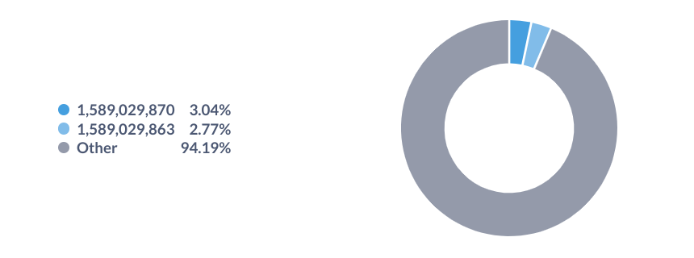

* + **براساس مقیاس کوچک شده‌ی 100000000 برابری**

|  |
| --- |
| **select** dest_wallet_id/100000000 dest_wallet_id, sum(swtc) result  **from**(  **select** dest_wallet_id, sum(transaction_value) swtv, sum(transaction_cost) swtc  **from**(  **select** dest_wallet_id, sum(new_count) wight, transaction_cost, transaction_value  **from**(  **select** *  **from**(  **select** dest_wallet_id, count(count) new_count, transaction_cost, transaction_value  **from** data_dataset  **where** count = 0  **group** **by** dest_wallet_id, transaction_cost, transaction_value) **as** b0    **union** all  **select** *  **from**(  **select** dest_wallet_id, count new_count, transaction_cost, transaction_value  **from** data_dataset  **where** count != 0) **as** b1) **as** b2  **group** **by** dest_wallet_id, transaction_cost, transaction_value) **as** b3  **group** **by** dest_wallet_id) **as** b4  **group** **by** dest_wallet_id/100000000  **order** **by** result **desc** |

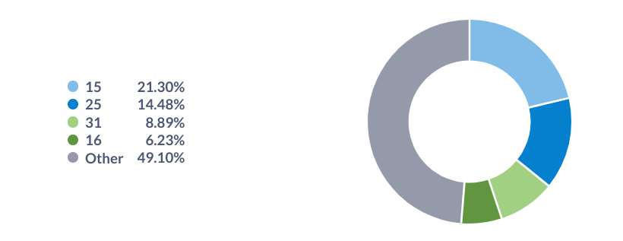

* **میانگین transaction_cost ها**
  + **براساس مقیاس معمولی**

|  |
| --- |
| **select** dest_wallet_id, sum(transaction_cost)/sum(wight) result  **from**(  **select** dest_wallet_id, sum(new_count) wight, transaction_cost, transaction_value  **from**(  **select** *  **from**(  **select** dest_wallet_id, count(count) new_count, transaction_cost, transaction_value  **from** data_dataset  **where** count = 0  **group** **by** dest_wallet_id, transaction_cost, transaction_value) **as** b0    **union** all  **select** *  **from**(  **select** dest_wallet_id, count new_count, transaction_cost, transaction_value  **from** data_dataset  **where** count != 0) **as** b1) **as** b2  **group** **by** dest_wallet_id, transaction_cost, transaction_value) **as** b3  **group** **by** dest_wallet_id  **order** **by** result **desc** |

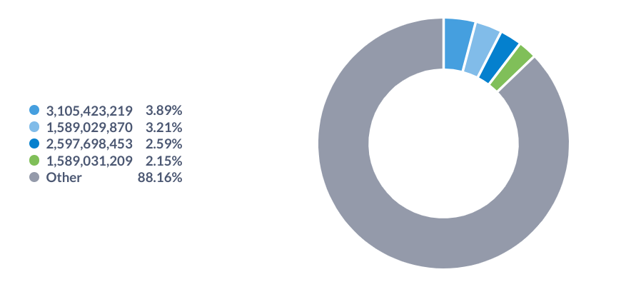

* + **براساس مقیاس کوچک شده‌ی 100000000 برابری**

|  |
| --- |
| **select** dest_wallet_id/100000000 dest_wallet_id, sum(result) result  **from**(  **select** dest_wallet_id, sum(transaction_cost)/sum(wight) result  **from**(  **select** dest_wallet_id, sum(new_count) wight, transaction_cost, transaction_value  **from**(  **select** *  **from**(  **select** dest_wallet_id, count(count) new_count, transaction_cost, transaction_value  **from** data_dataset  **where** count = 0  **group** **by** dest_wallet_id, transaction_cost, transaction_value) **as** b0    **union** all  **select** *  **from**(  **select** dest_wallet_id, count new_count, transaction_cost, transaction_value  **from** data_dataset  **where** count != 0) **as** b1) **as** b2  **group** **by** dest_wallet_id, transaction_cost, transaction_value) **as** b3  **group** **by** dest_wallet_id) **as** b4  **group** **by** dest_wallet_id/100000000  **order** **by** result **desc** |

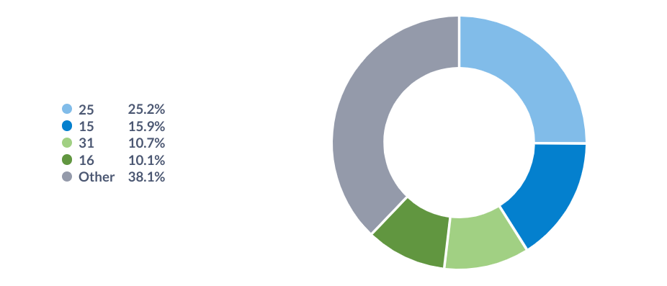

* **میانگین transaction_value ها**
  + **براساس مقیاس معمولی**

|  |
| --- |
| **select** dest_wallet_id, sum(transaction_value)/sum(wight) result  **from**(  **select** dest_wallet_id, sum(new_count) wight, transaction_cost, transaction_value  **from**(  **select** *  **from**(  **select** dest_wallet_id, count(count) new_count, transaction_cost, transaction_value  **from** data_dataset  **where** count = 0  **group** **by** dest_wallet_id, transaction_cost, transaction_value) **as** b0    **union** all  **select** *  **from**(  **select** dest_wallet_id, count new_count, transaction_cost, transaction_value  **from** data_dataset  **where** count != 0) **as** b1) **as** b2  **group** **by** dest_wallet_id, transaction_cost, transaction_value) **as** b3  **group** **by** dest_wallet_id  **order** **by** result **desc** |

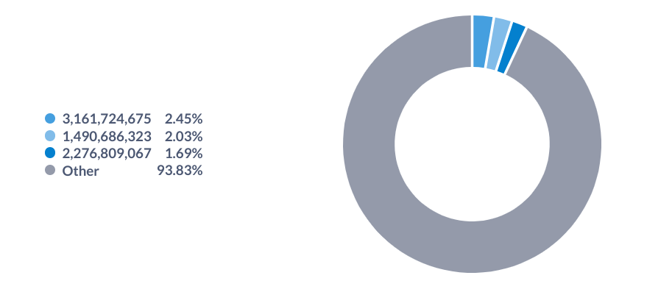

* + **براساس مقیاس کوچک شده‌ی 100000000 برابری**

|  |
| --- |
| **select** dest_wallet_id/100000000 dest_wallet_id, sum(result) result  **from**(  **select** dest_wallet_id, sum(transaction_value)/sum(wight) result  **from**(  **select** dest_wallet_id, sum(new_count) wight, transaction_cost, transaction_value  **from**(  **select** *  **from**(  **select** dest_wallet_id, count(count) new_count, transaction_cost, transaction_value  **from** data_dataset  **where** count = 0  **group** **by** dest_wallet_id, transaction_cost, transaction_value) **as** b0    **union** all  **select** *  **from**(  **select** dest_wallet_id, count new_count, transaction_cost, transaction_value  **from** data_dataset  **where** count != 0) **as** b1) **as** b2  **group** **by** dest_wallet_id, transaction_cost, transaction_value) **as** b3  **group** **by** dest_wallet_id) **as** b4  **group** **by** dest_wallet_id/100000000  **order** **by** result **desc** |

